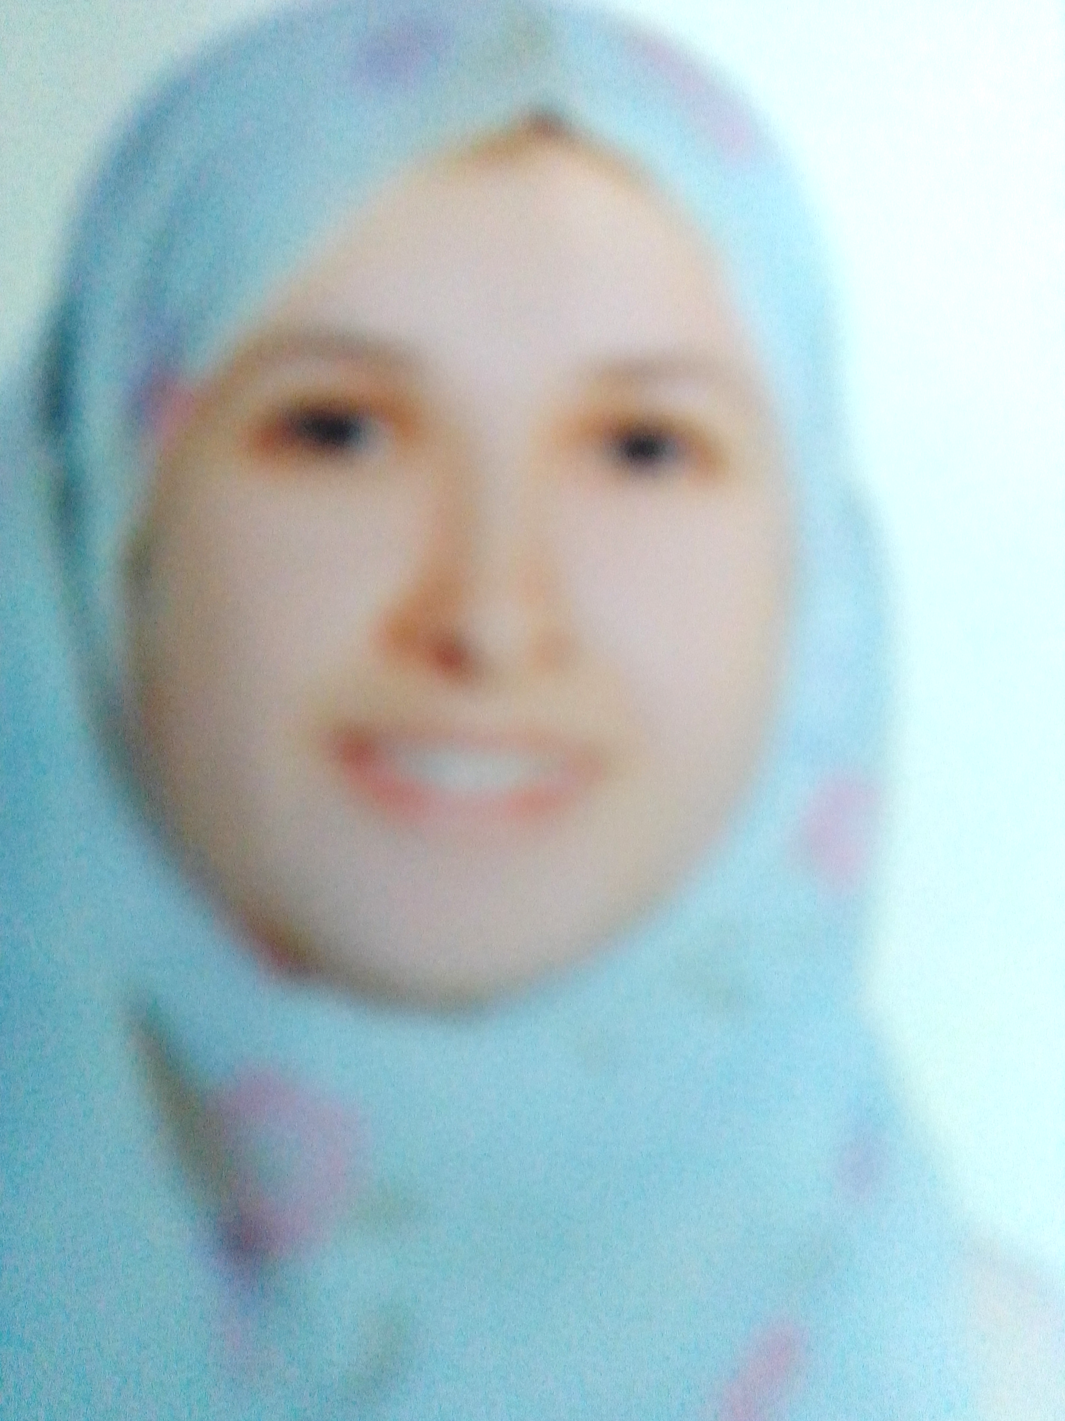 |  | Nesrine Saleh  A Doctor of Clinical Pathology
Contact  PHONE:  01228822048  EMAIL:  Dr.nesrinesaleh@gmail.com  Nesrine.Saleh@rio.sci.eg |  | EDUCATION  Bachelorly of medicine and surgery  Faculty of medicine Kasr Al-Ainy  2000 - 2006  Master's degree in 2017  Field: Clinical and chemical Pathology  WORK EXPERIENCE  Research Institute of Ophthalmology Lecturer Assistant  From 2017to 2021  - Laboratory worker since 2008. Expert of PCR and stem cell researcher  - Gained proficiency in basic laboratory skills: solution making, sterile technique, proper use of basic lab tools and equipment, safe handling of hazardous materials.  - Gained experience in molecular biology: PCR, gel electrophoresis, RFLP technique, western blotting, chromatography and spectrophotometry.  Language: speaking English and French  SKILLS  - Computer skills (Word, Excel, power point representation)  - Teamwork and cooperation with other team in the lab in the use of equipment and supplies.

